# Probability

**Probability:**  the likelihood of an event occurring

The probability of an event must be in between 0 and 1

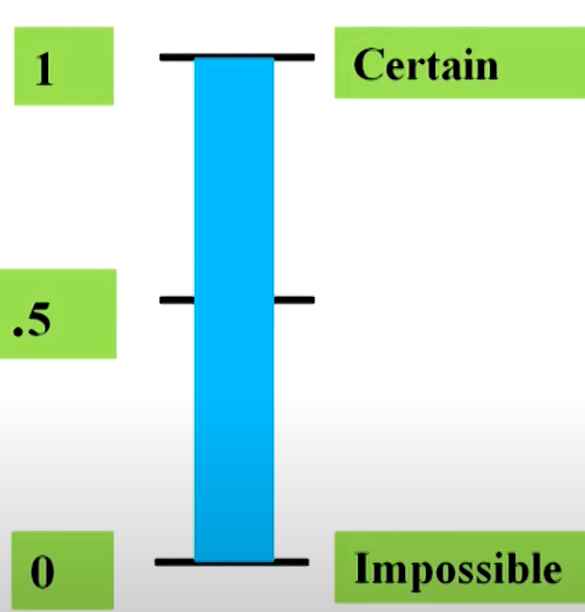

**1. Experiment**

An **experiment** is any process that gives some outcomes.  
👉 **Example:** Rolling a die is an experiment because we get a number between 1 and 6.

**2. Sample Space (S)**

The **sample space** is the set of all possible outcomes of an experiment.  
👉 **Example:** When rolling a die, the sample space is:

S={1,2,3,4,5,6}

**3. Elementary Events**

An **elementary event** is an event that contains only **one** outcome.  
👉 **Example:** Getting a 3 when rolling a die is an elementary event:

E={3}

**4. Event**

An **event** is any collection of one or more outcomes from the sample space.  
👉 **Example:** Getting an **even number** when rolling a die is an event:

E={2,4,6}

**5. Union of Events (A∪B)**

The **union** of two events means **either one or both** of them happen.  
👉 **Example:**

* Event A: Getting an even number {2,4,6}
* Event B: Getting a number greater than 4 {5,6}
* A∪B = {2,4,5,6} (Numbers that are in either A or B or both)

**6. Intersection of Events (A∩B)**

The **intersection** of two events means both events happen **together**.  
👉 **Example:**

* A∩B={6} (Only 6 is both even and greater than 4)

**7. Mutually Exclusive Events**

Two events are **mutually exclusive** if they **cannot** happen at the same time.

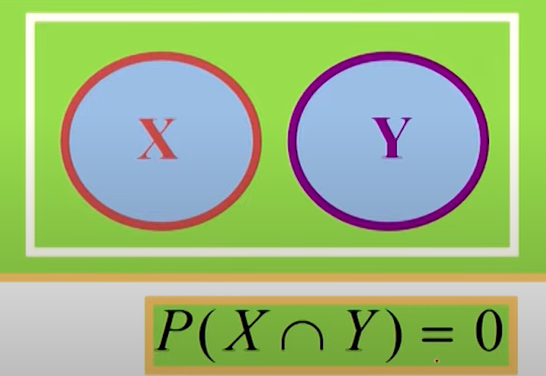  
👉 **Example:**

* A= Getting an even number {2,4,6}
* C= Getting an odd number {1,3,5}
* A∩C=∅ (No common outcome)  
  🔹 **Conclusion:** You **cannot** get both an even and an odd number at the same time!

**8. Independent Events**

Two events are **independent** if the outcome of one does **not** affect the other.  
👉 **Example:** Rolling a die **and** flipping a coin are independent because rolling a die does not change the probability of getting heads.

**9. Collectively Exhaustive Events**

A set of events is **collectively exhaustive** if **at least one of them must happen**.  
👉 **Example:**

* A= Getting an even number {2,4,6}
* C= Getting an odd number {1,3,5}  
  🔹 These two events together **cover all possible outcomes** {1,2,3,4,5,6}so they are **collectively exhaustive**.

**10. Complementary Events**

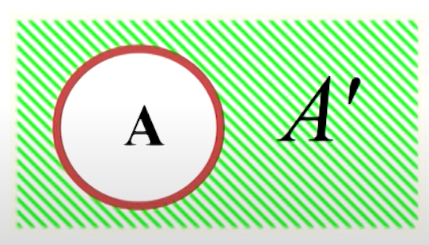

The **complement** of an event A is everything **not in A**.  
👉 **Example:**

* A= Getting a number less than 4 {1,2,3}
* **Complement of A (Ac)** = Getting a number 4 or more {4,5,6}  
  🔹 **Conclusion:** Either you get a number **less than 4** or **4 or more**—no other possibility!

## Methods of assigning probabilities

1. Classical method of assigning probabilities (rules and laws)
2. Relative frequency of occurrence (cumulated historical data)
3. Subjective Probability (personal intuition or reasoning)
4. Classical probability:

Used when all outcomes are **equally likely**.

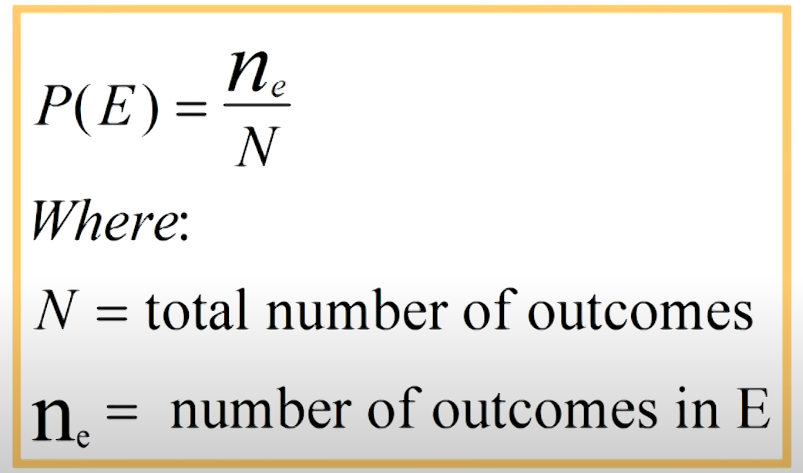

1. Relative frequency: Same formula like above.

Based on **experiments or past data**.

1. Subjective probability:

Based on **personal judgment or belief**, not on exact calculations or experiments.

## Methods for describing a sample space

1. **Roster or Listing**

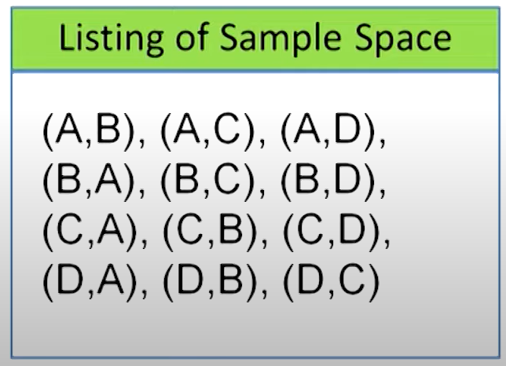

**2. Tree Diagram**

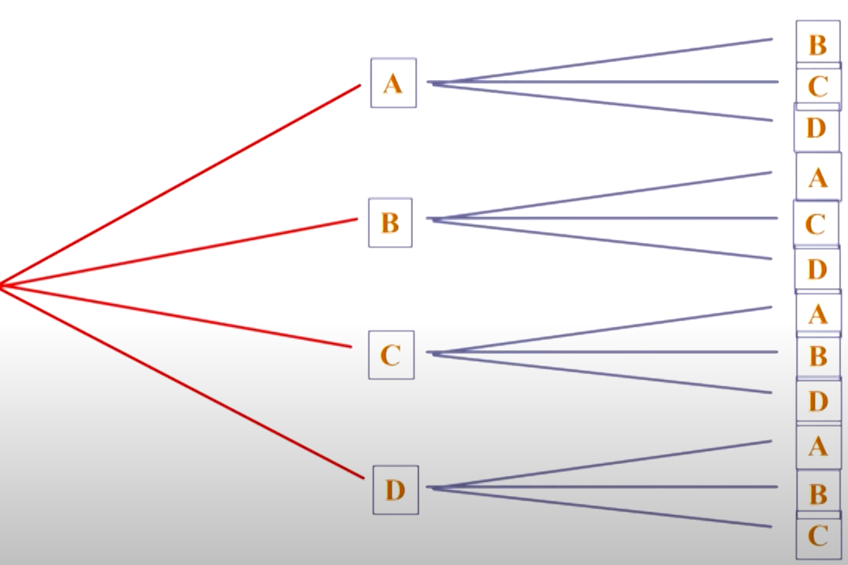

**3. Set Builder Notation: S={x,y |}**

**4. Venn Diagram**

## Counting the possibilities

### **1. Multiplication Principle (Mn Rule)**

The **Multiplication Rule (Mn Rule)** states that if an experiment consists of **multiple independent staes**, where:

### 2. Sampling from a Population

When selecting items from a group (population), there are two main ways to sample:

* 1. **Sampling With Replacement**
* **Definition:** After selecting an item, you put it back into the population before selecting again.

**Example:**

* Suppose you have a jar with 5 colored balls (Red, Blue, Green, Yellow, White).
* If you pick a ball, note its color, and **put it back**, the next selection still has **5 balls to choose from**.
* If you pick 3 times, the number of ways = 5×5×5=1255 \times 5 \times 5 = 1255×5×5=125.
  1. **Sampling Without Replacement(Combinations)**
* **Definition:** After selecting an item, you do not put it back into the population.

**Example:**

* Suppose you have a deck of 52 playing cards.
* If you draw a card and do **not** return it, the next draw will have **only 51** cards left.
* If you pick 3 times, the number of ways = 52×51×5052 \times 51 \times 5052×51×50.
* 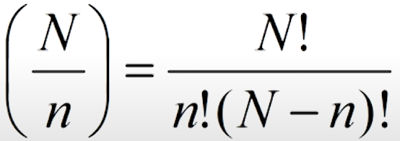

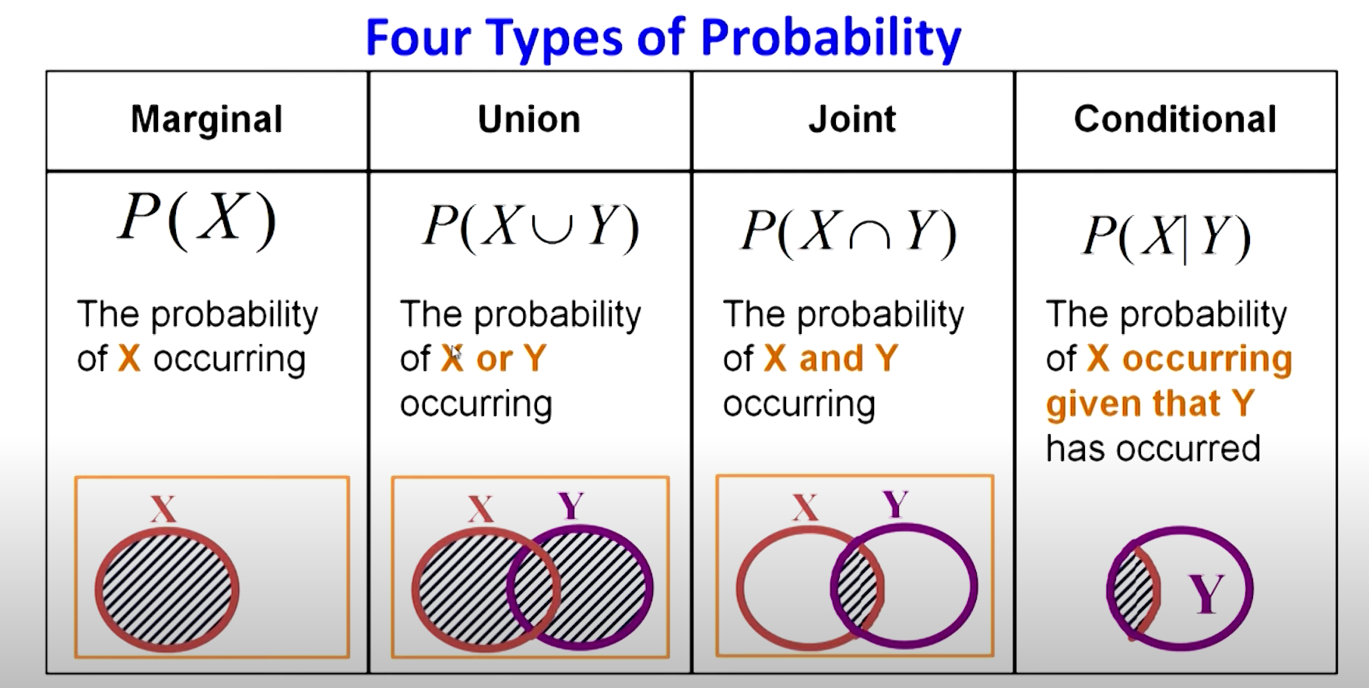

## Addition Law

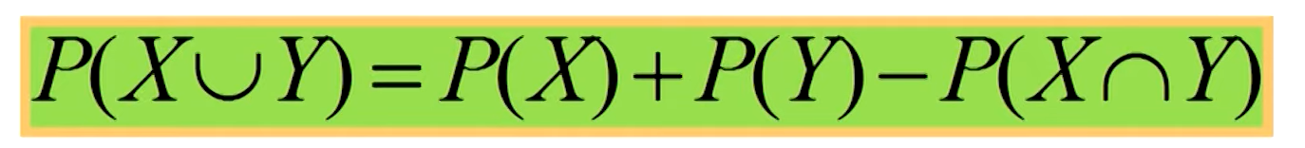

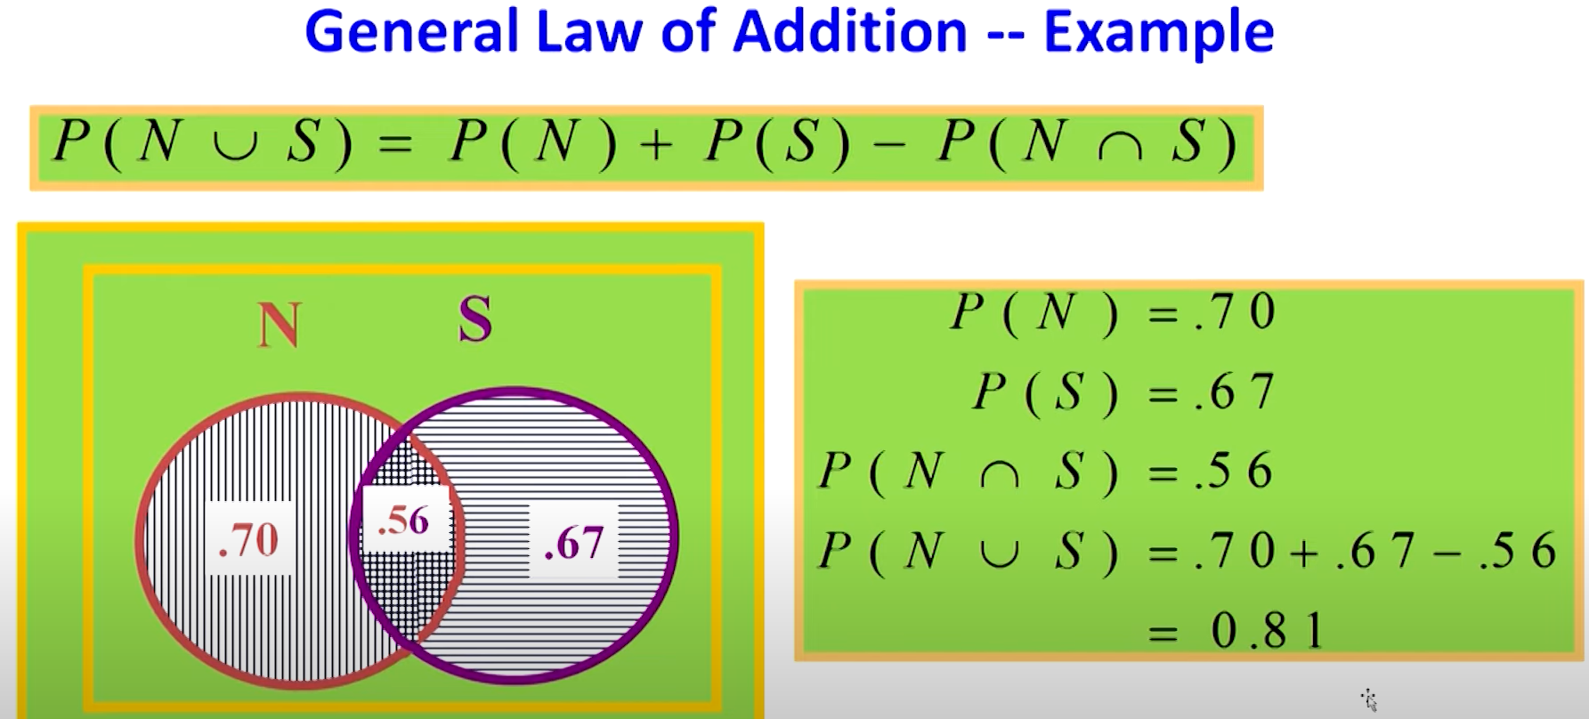

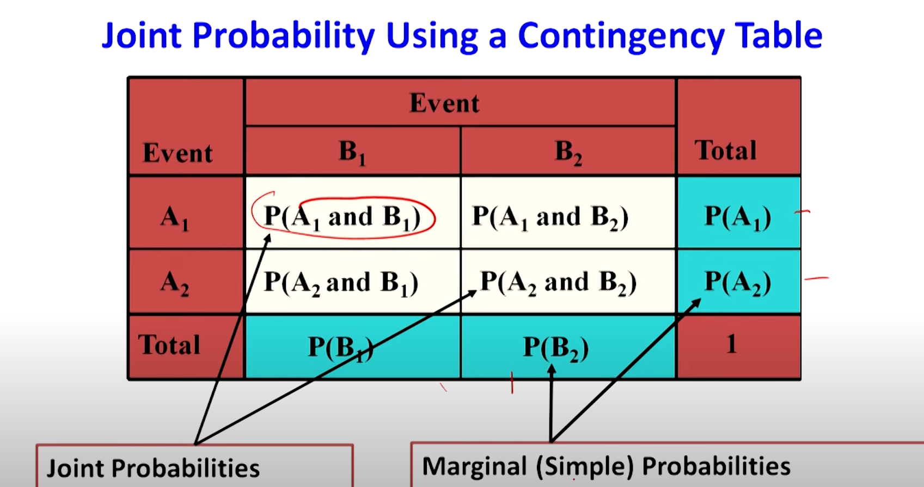

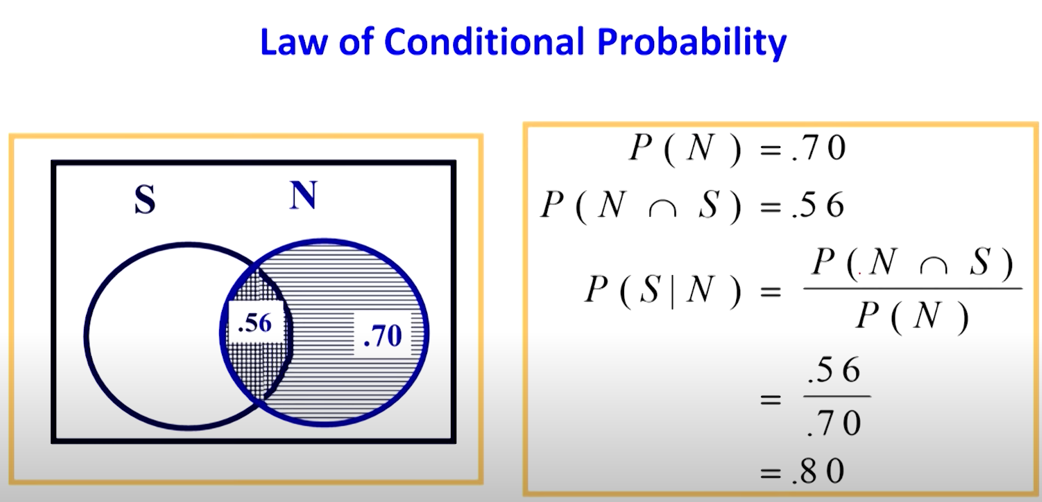

**1. Raw Values Matrix**

A **raw values matrix** is a table that contains the actual collected data in its original form, without any processing or summarization

**2. Contingency Matrix (Contingency Table)**

A **contingency matrix** (or **contingency table**) is a table used in statistics to show the **frequency of occurrence** of different categories in two or more variables. It is commonly used in **categorical data analysis**.

### Law of Multiplication

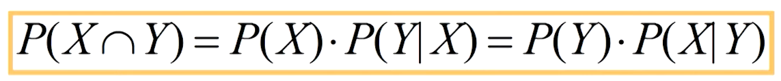

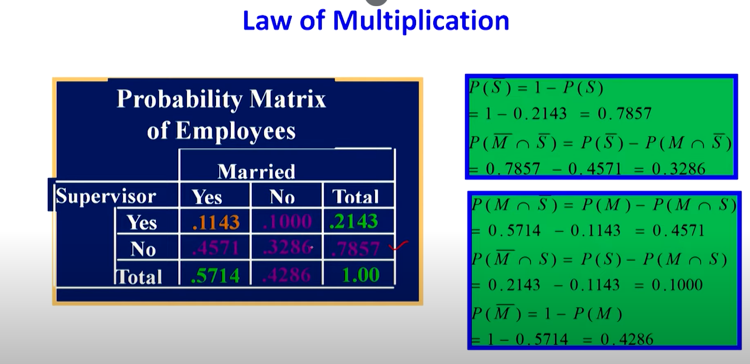

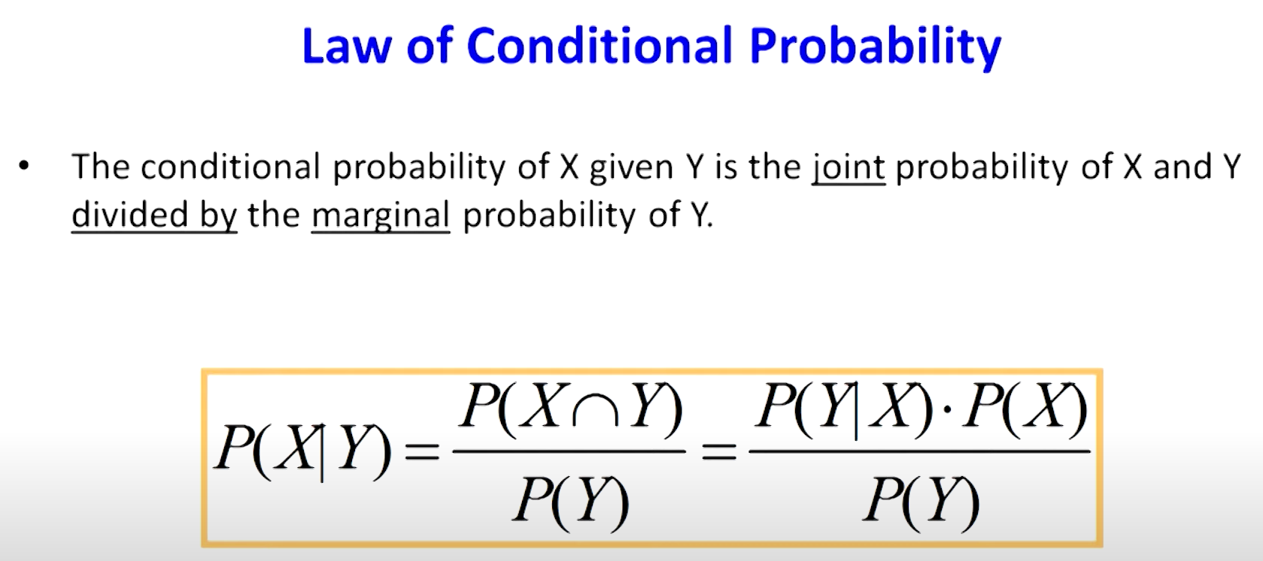

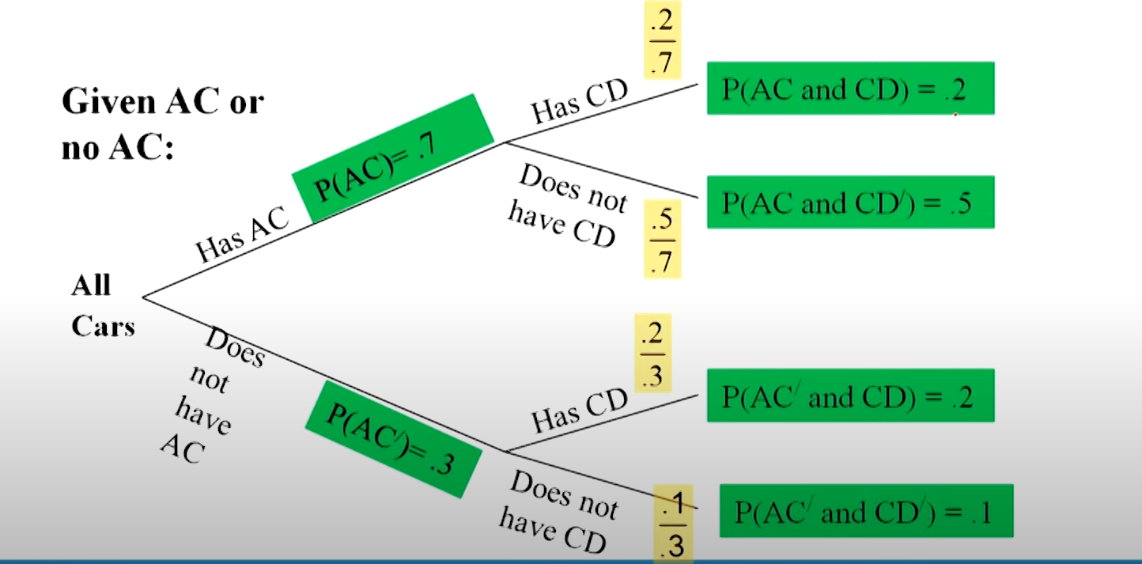

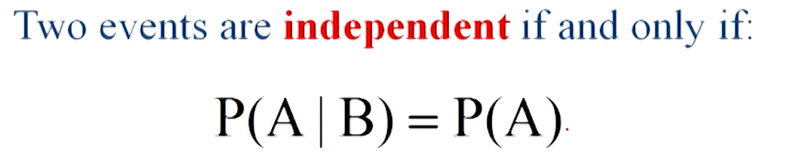

## Bayes Theorem (bayes’ Rule)

An extension to the conditional probability, it is like a revision of probabilities

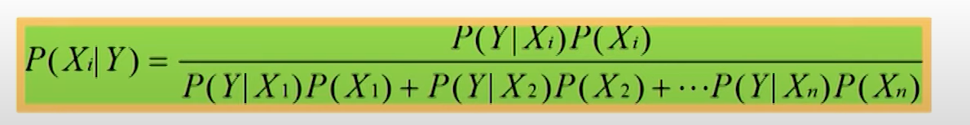

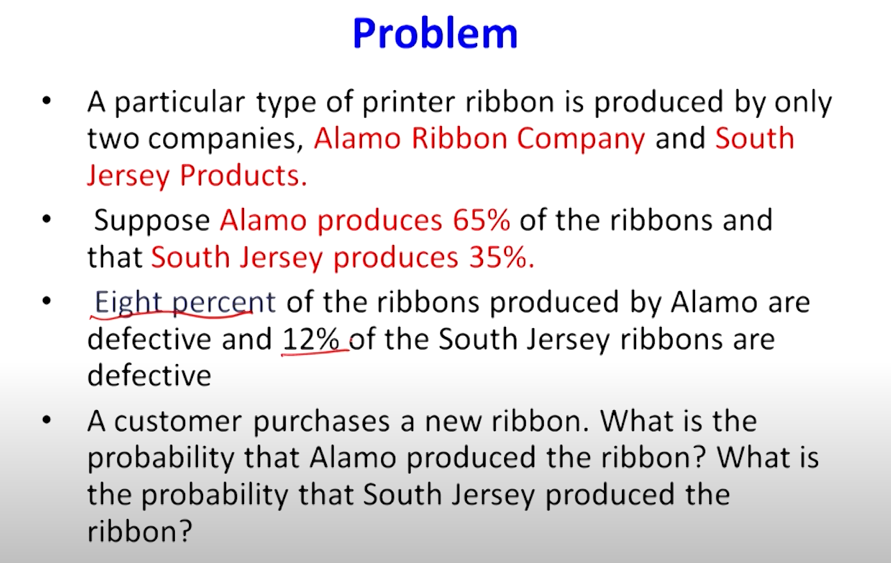

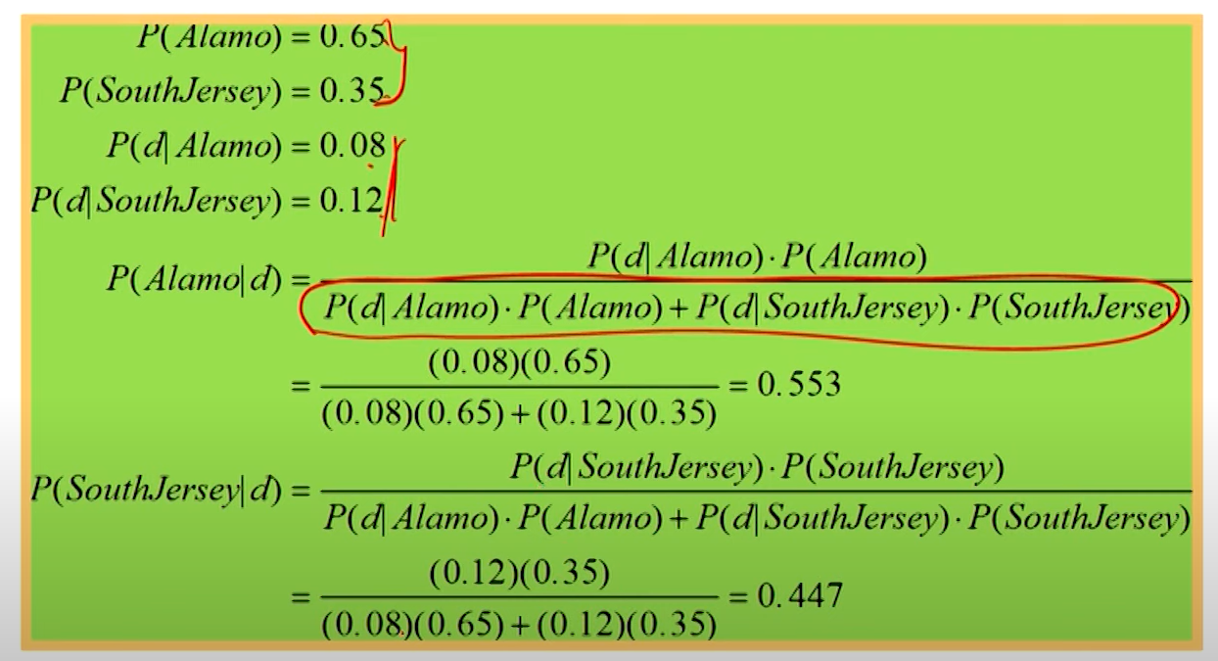

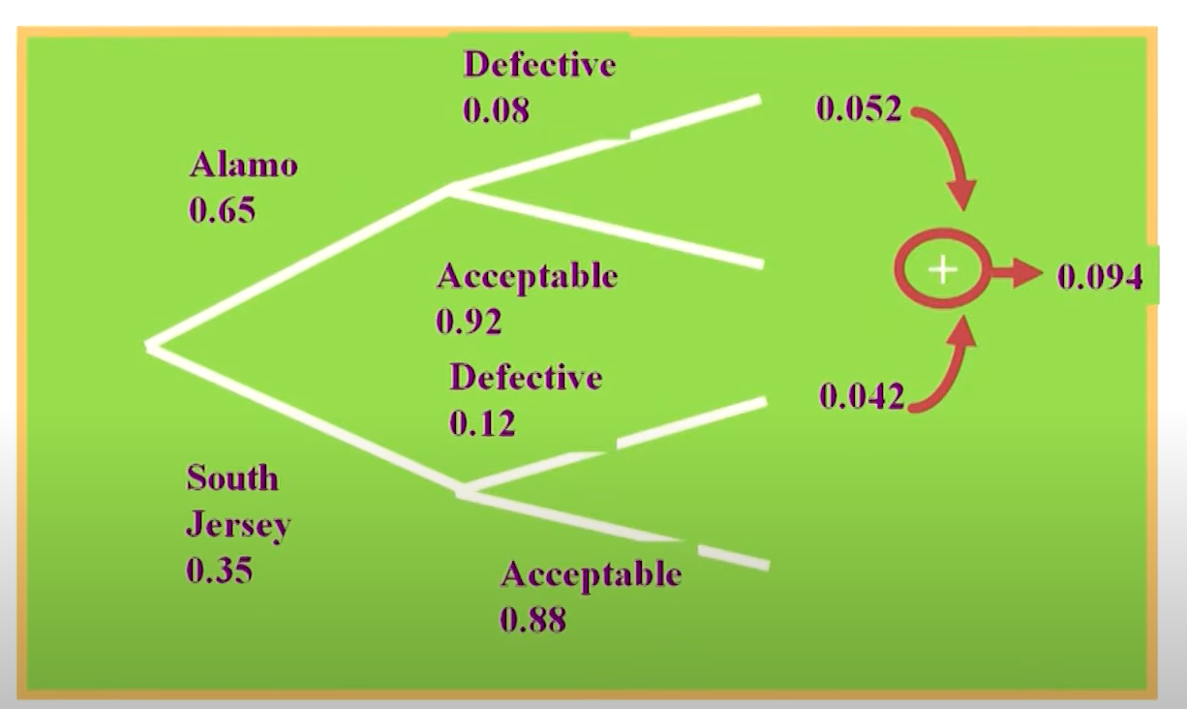

# Combinatorics (Permutations & Combinations)

## Permutations:- {Apple, Banana} =/ {Banana, Apple}

## Combinations:- {Apple, Banana} == {banana, Apple}

# Distributions

* + - * Shape of set of numbers

**Random variable**: A **random variable** is a variable that takes on numerical values based on the outcome of a random experiment.

* + - * Discreate: Takes on a countable number of values (e.g., integers).
      * Continuous: Takes on an uncountable number of values (e.g., real numbers).

### **Probability Distribution**

A **probability distribution** describes how probabilities are assigned to different possible outcomes of a random variable. It gives insights into the likelihood of each outcome occurring

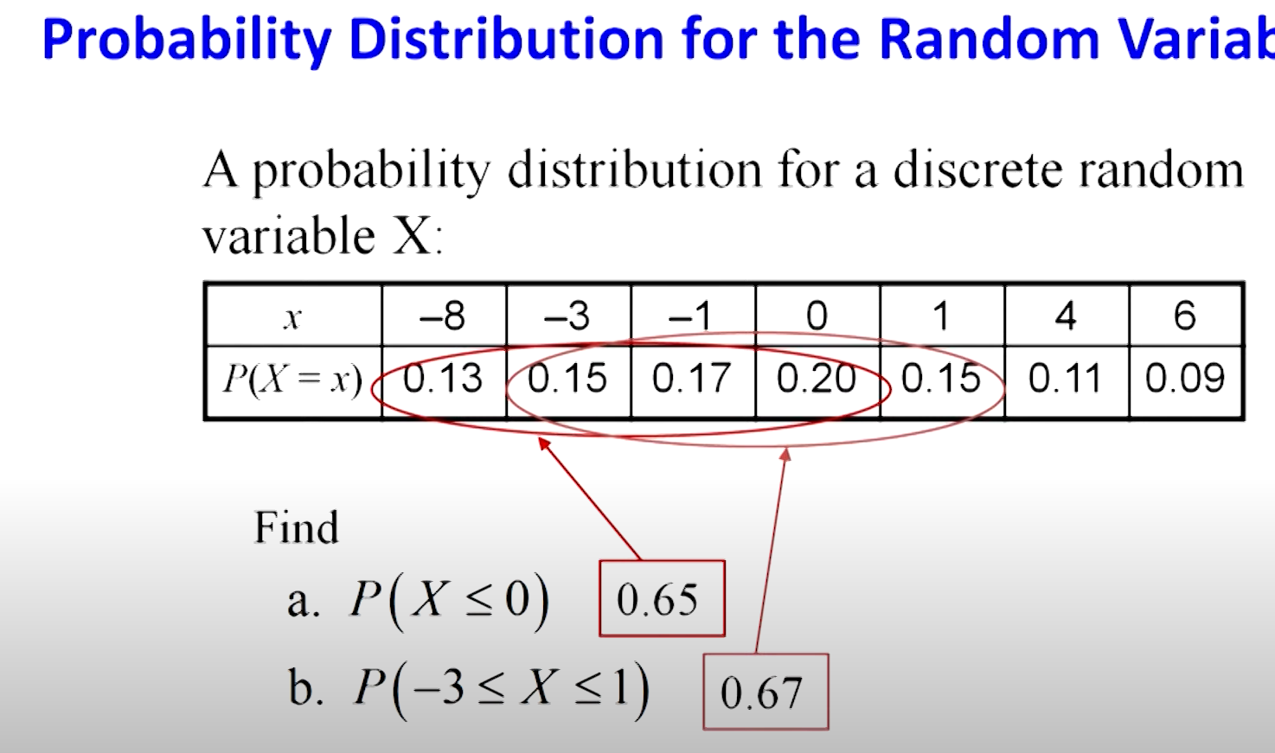

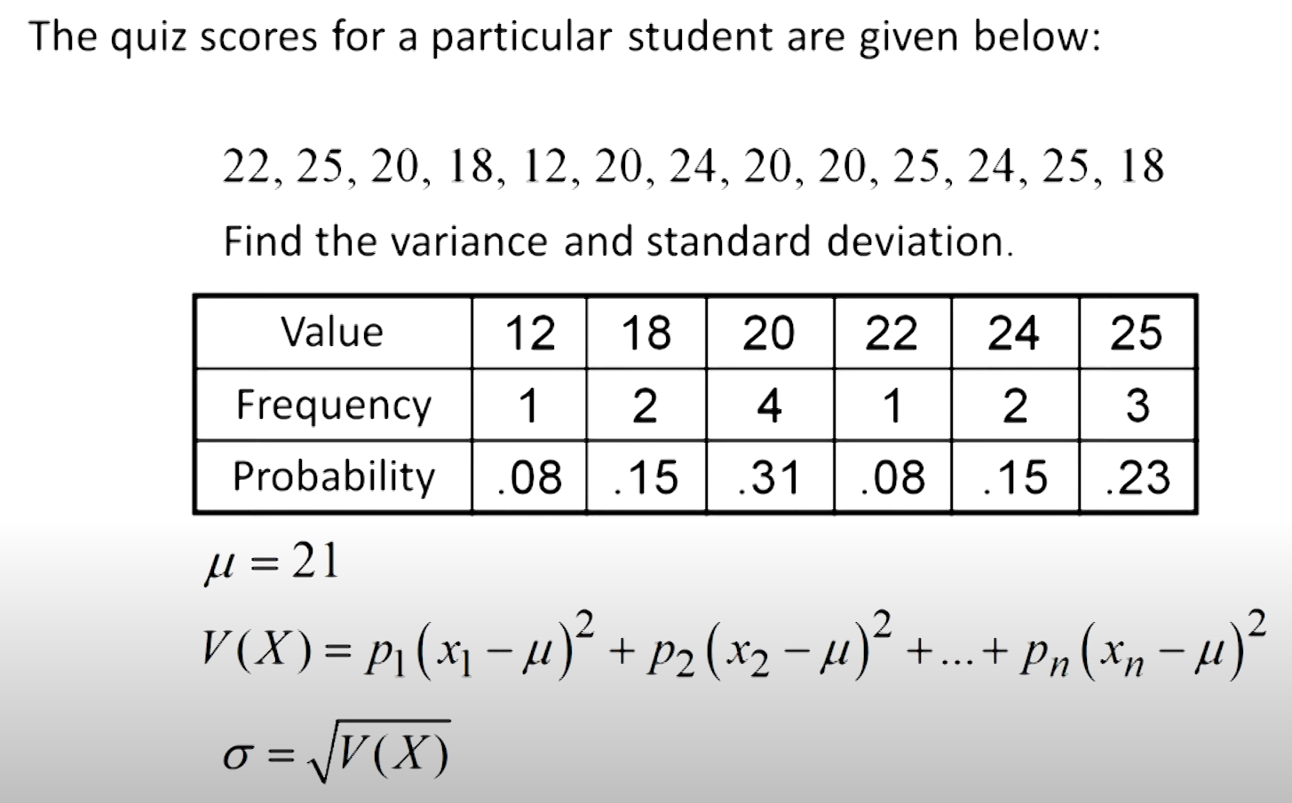

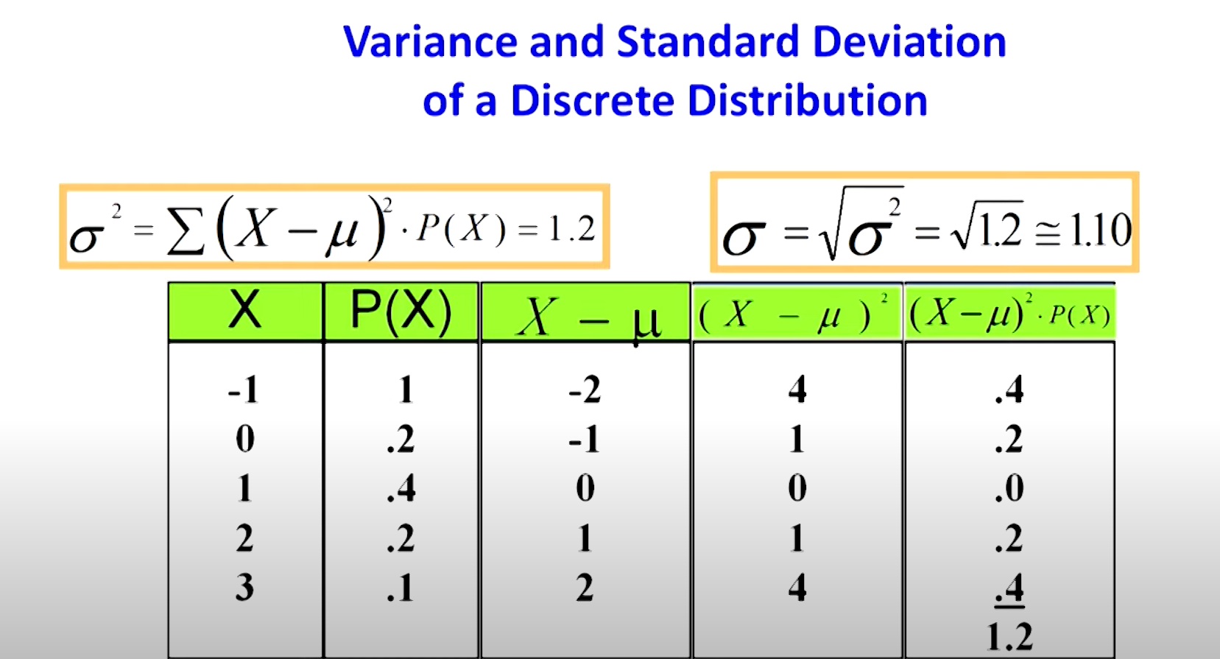

Some special distributions

1. Discrete:
   1. Binomial
   2. Poisson
   3. Hyper geometric
2. Continuous:
   1. Uniform
   2. Exponential
   3. Normal

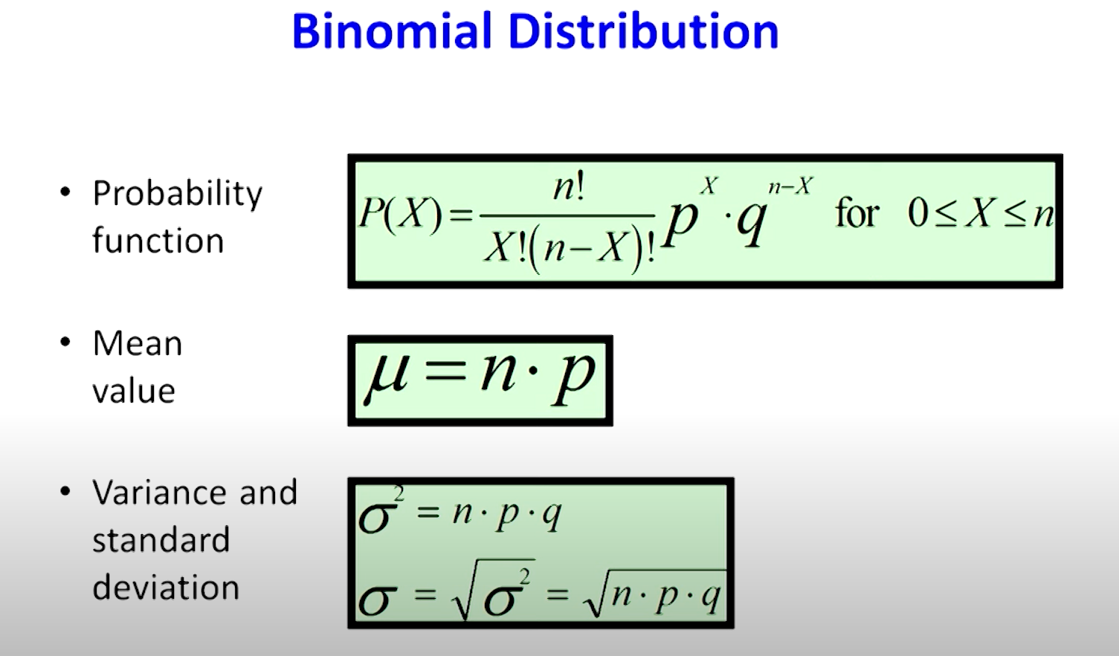

**Poisson Distribution**

The **Poisson Distribution** is a probability distribution that models the **number of times an event occurs in a fixed interval of time or space**, given that the events occur independently and at a constant average rate.

It is useful when dealing with rare or random events that happen over **time, distance, area, or volume**.

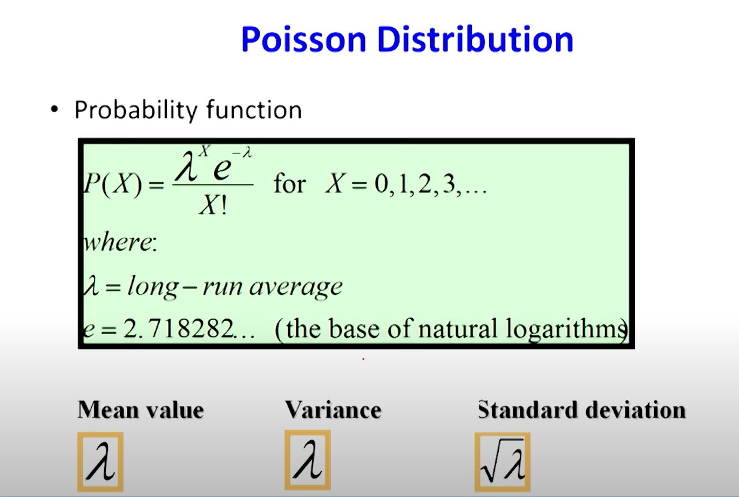

**Hypergeometric Distribution**

The **Hypergeometric Distribution** is a probability distribution that describes the **number of successes in a fixed number of draws from a finite population, without replacement.**

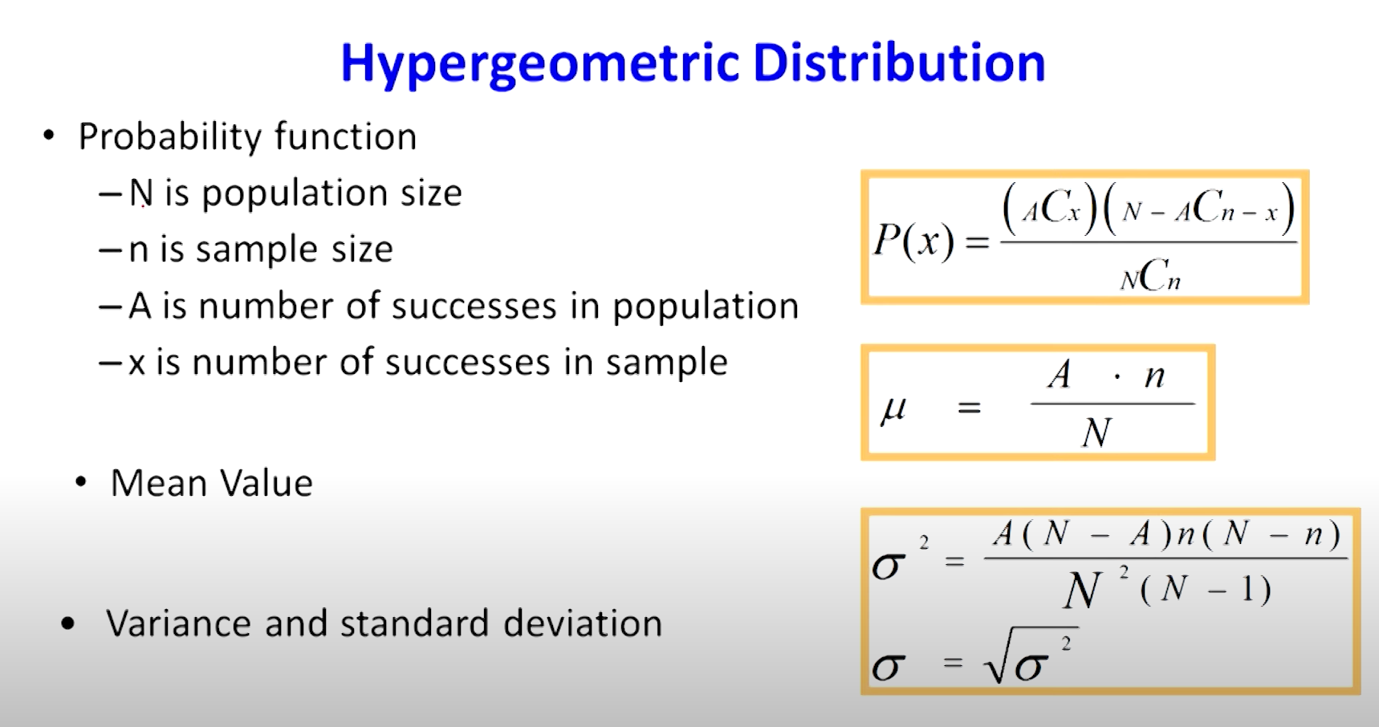

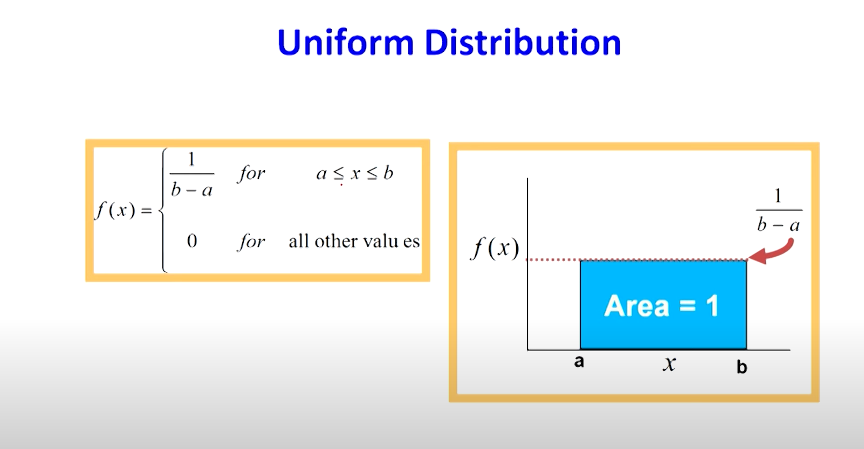

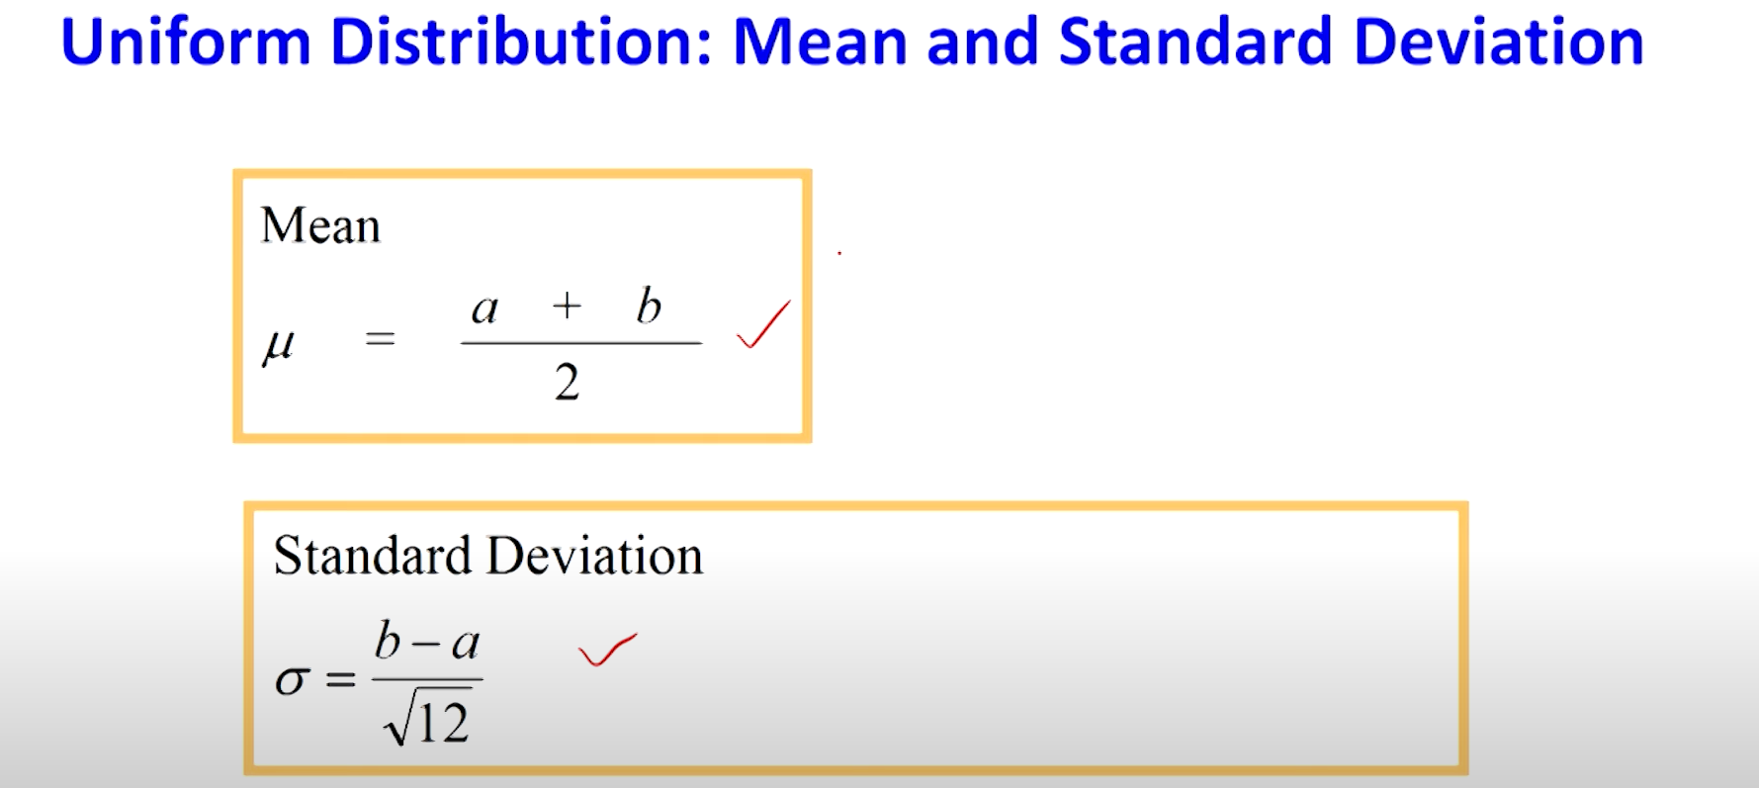

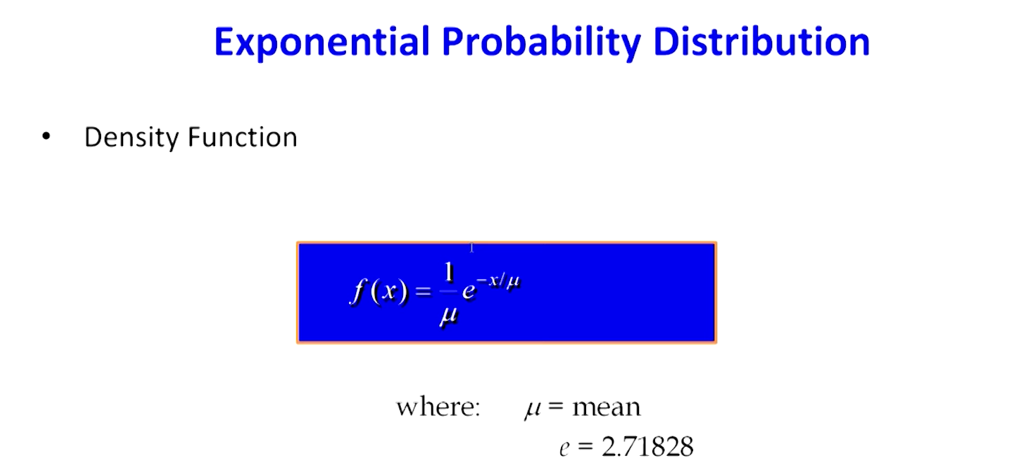

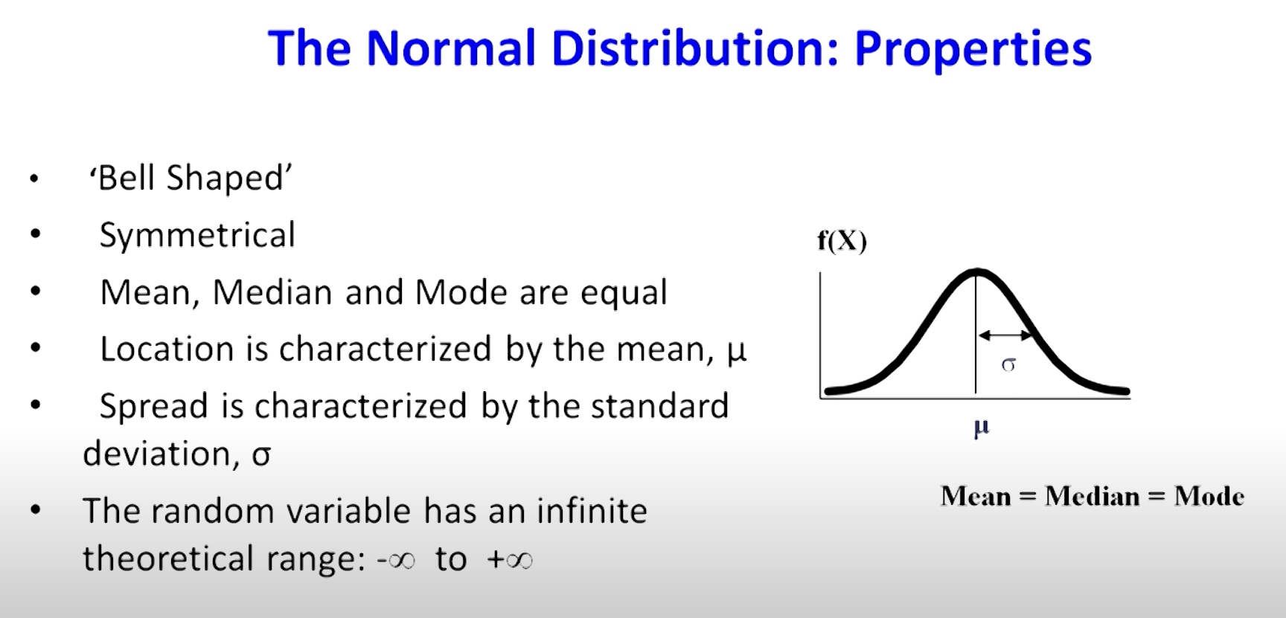

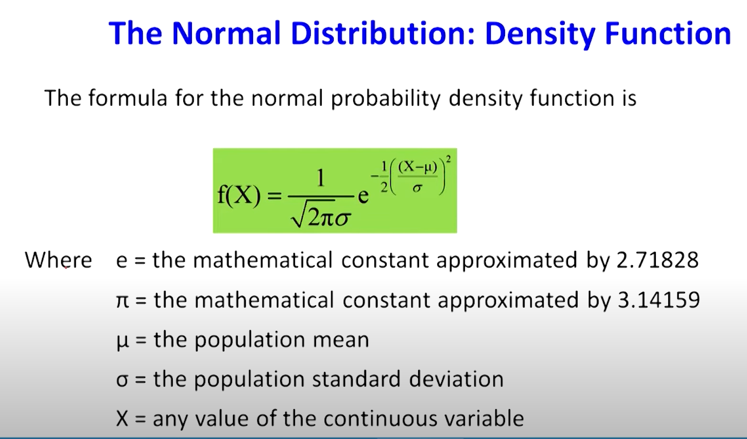

| **Distribution** | **Type** | **When to Use?** | **Key Characteristics** | **Example** |
| --- | --- | --- | --- | --- |
| **Binomial** | Discrete | When there are **exactly 2 outcomes** (Success/Failure) and a **fixed number of trials (n)** | - Independent trials - Probability of success remains constant | Tossing a coin **10 times** and counting heads |
| **Poisson** | Discrete | When counting the **number of events** in a fixed **time or space** | - Events occur randomly and independently - Fixed average rate (λ) | Number of **calls received per hour** at a call center |
| **Hypergeometric** | Discrete | When selecting **without replacement** | - Trials are dependent (probability changes) | Drawing **5 defective items** from a batch of **20 items** without replacement |
| **Uniform** | Can be Discrete or Continuous | When **all outcomes have the same probability** | - Every outcome is equally likely | - Rolling a **fair die** 🎲 (Discrete) - Choosing a **random number between 0 and 10** (Continuous) |
| **Exponential** | Continuous | When calculating **time until next event occurs** | - Probability **decreases exponentially** over time - Memoryless property | **Time until next customer** arrives at a shop |
| **Normal (Gaussian)** | Continuous | When data is **symmetrically distributed** around a mean | - Bell-shaped curve - Mean = Median = Mode - Follows the **68-95-99.7 Rule** | **Heights of people**, IQ scores, exam scores |

## Random sampling Techniques

**1️. Simple Random Sampling (SRS)**

* Every individual in the population has an **equal** chance of being selected.
* Selection is done randomly using methods like **lottery** or **random number generators**.

🔹 *Example:* Picking 10 employees randomly from a company’s employee list.

**2️. Systematic Sampling**

* The first individual is selected randomly, and then every **k-th** individual is chosen.
* The interval **k** is calculated as: k=Population SizeSample Sizek = \frac{\text{Population Size}}{\text{Sample Size}}k=Sample SizePopulation Size​

🔹 *Example:* Selecting every 5th passenger from a flight booking list.

**3️. Stratified Sampling**

* The population is divided into **homogeneous subgroups (strata)** based on characteristics (e.g., age, gender, income).
* A **random sample** is taken from each group **proportionally**.

🔹 *Example:* In a university survey, randomly selecting students from each department (e.g., 10 from Engineering, 10 from Arts, etc.).

**4️. Cluster Sampling**

* The population is divided into **heterogeneous groups (clusters)**.
* A **few clusters** are randomly selected, and **all individuals** within those clusters are included in the sample.

🔹 *Example:* Instead of surveying all schools in a state, randomly selecting 5 schools and surveying all students in those schools.

## Non-Random Sampling Techniques (Non-Probability Sampling)

Non-random sampling means that **not everyone has an equal chance of being selected**. The researcher picks samples based on convenience, judgment, or specific criteria instead of random selection.

**Types of Non-Random Sampling:**

**1️. Convenience Sampling (Easiest to reach)**

* People are chosen because they are **easily available**.
* ✅ **Quick & cheap** but **may not represent the whole population**.

🔹 *Example:* Asking your friends to fill out a survey instead of randomly selecting people from a city.

**2️. Judgmental (Purposive) Sampling (Expert choice)**

* The researcher **chooses** people based on **who they think is best for the study**.
* ✅ Good for **specialized research**, but **biased** because it depends on the researcher's choice.

🔹 *Example:* Interviewing **only experienced doctors** about a new treatment instead of including all doctors.

**3️. Quota Sampling (Fixed number from each group)**

* The population is **divided into groups**, and a **set number (quota) of people** is taken from each.
* ✅ Ensures **each group is included**, but **not randomly selected**.

🔹 *Example:* Choosing **50 men and 50 women** for a study instead of picking randomly.

**4️. Snowball Sampling (People refer others)**

* **One person is chosen first, and they recommend others** who fit the study.
* ✅ Useful for **rare or hidden groups**, but **may not be diverse**.

🔹 *Example:* Studying **drug addiction** by first interviewing one person, who then introduces more participants.

## Difference between descriptive and inferential statistics

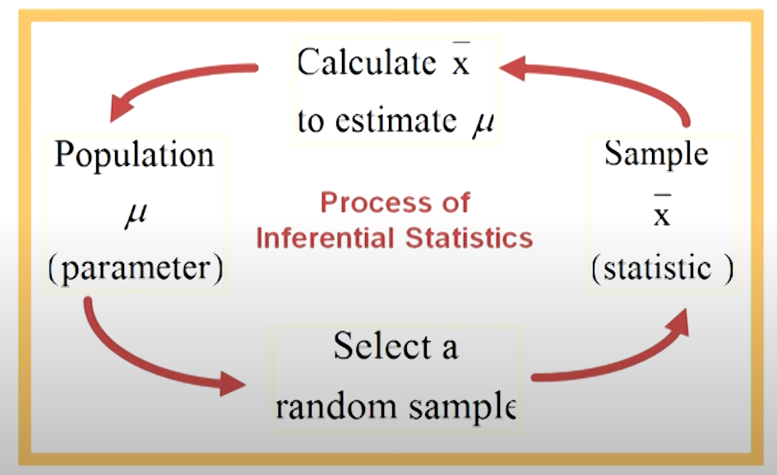

**Descriptive statistics**

It refers to methods used to summarize and organize data. It helps in understanding the characteristics of a dataset without making predictions or generalizations. These methods include:

* **Measures of Central Tendency** (Mean, Median, Mode)
* **Measures of Dispersion** (Variance, Standard Deviation, Range, IQR)
* **Data Visualization** (Histograms, Pie Charts, Box Plots, Scatter Plots)

**Inferential Statistics**

Inferential statistics involves drawing conclusions and making predictions about a population based on a sample of data.

Population means set of all items

Sample means it is a subset of the population

## Sampling distribution

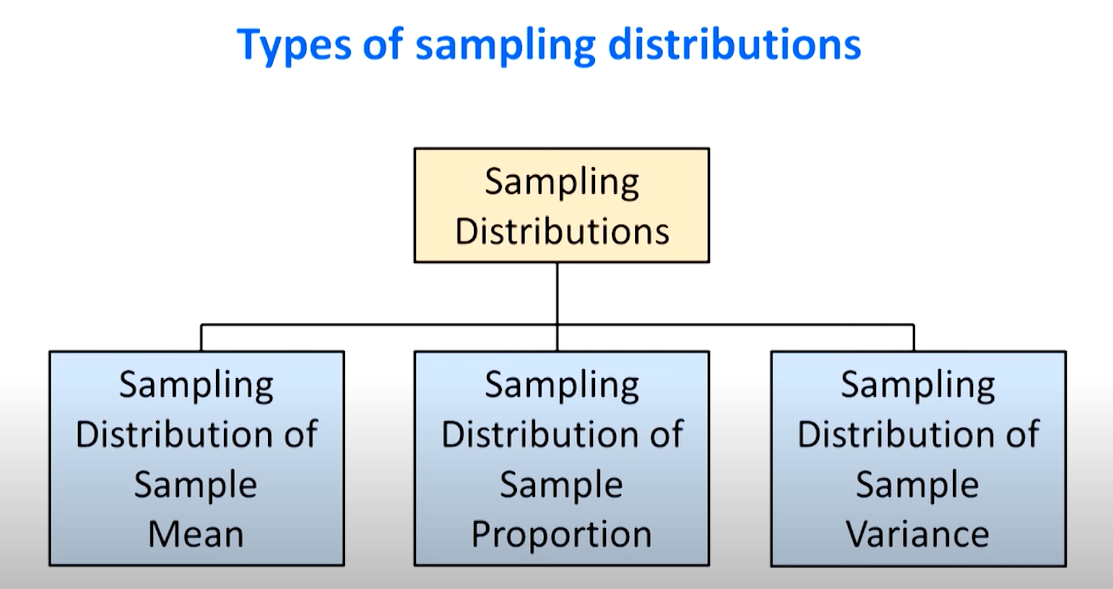

The **Central Limit Theorem (CLT)** states that if you take a large number of **random samples** from any population, the **sampling distribution of the sample mean** will be approximately **normal (bell-shaped)**, **regardless of the original population's shape**.

An acceptance interval is an interval [L,U][L, U][L,U] within which a test statistic or sample value is accepted under a null hypothesis (H0H_0H0​). If the observed value falls **outside** this interval, the null hypothesis is rejected.

**Understanding Sampling Distributions in the Easiest Way**

Imagine you have a big jar full of marbles of different colors. You want to know **the average number of red marbles** in small handfuls you pick. But instead of counting all the marbles in the jar, you take small samples (handfuls) and calculate an average for each sample.

Now, if you keep taking samples and recording their averages, you will get a **distribution of averages**—this is called a **sampling distribution**!

**1. Sampling Distribution of the Sample Mean (Average)**

This tells us how the **average** (mean) of different samples behaves.

🔹 **Example:**  
Suppose the average weight of all students in a school is **60 kg**.

* You take **5 different samples**, each containing **30 students**.
* You calculate the average weight for each sample.
* If you plot all the sample means, you will see a pattern: most sample means are **close to 60 kg**.

💡 **Key Idea:**  
If you take many samples, the **average of all the sample means** will be close to the **true population mean**.

📌 **Rule:** The more samples you take, the more **normal (bell-shaped)** the distribution of sample means becomes (this is called the **Central Limit Theorem**).

**2. Sampling Distribution of the Sample Proportion**

This tells us how **proportions** (percentages) from samples behave.

🔹 **Example:**  
Imagine that **40% of students in a school like football**.

* You take **multiple random samples** of 50 students.
* You find that **in one sample, 38% like football**, in another, **42% like football**, and so on.
* If you plot all these sample proportions, you get a **distribution of proportions**.

💡 **Key Idea:**  
If you take many samples, the **average of all sample proportions** will be close to the **true population proportion (40%)**.

📌 **Rule:** If the sample size is large, the sample proportion will follow a **normal distribution**.

**3. Sampling Distribution of the Sample Variance**

This tells us how the **spread (variance)** of different samples behaves.

🔹 **Example:**

* Suppose the heights of students in a school are **not the same**—some are short, some are tall.
* If you take **different samples** and calculate the **variance** (how much the heights differ within each sample), each sample will have a different variance.
* If you plot all these sample variances, you get a **distribution of variances**.

💡 **Key Idea:**  
The variance from different samples is **not normally distributed** but follows a **chi-square distribution** (a different type of curve).

📌 **Rule:** The **more samples you take, the better the estimate of population variance**.

The **Chi-Square test** is used to check **whether the sample data represents the actual population** or if the observed differences are just due to **random chance**.

**Degrees of Freedom (df)**

Degrees of Freedom (df) refer to the number of values in a calculation that are free to vary while still following certain conditions.

Think of it like this:

🔹 Example: Suppose you are choosing 3 numbers that must add up to 15.

* You can freely choose the first two numbers (e.g., 5 and 6).
* But the third number is fixed (it must be 4 to make the sum 15).
* So, you had 2 free choices → Degrees of Freedom = 2.

**🔹 Estimator →** A formula or method used to estimate a population parameter**.  
🔹 Estimate →** A numerical value obtained when applying the estimator to a sample.

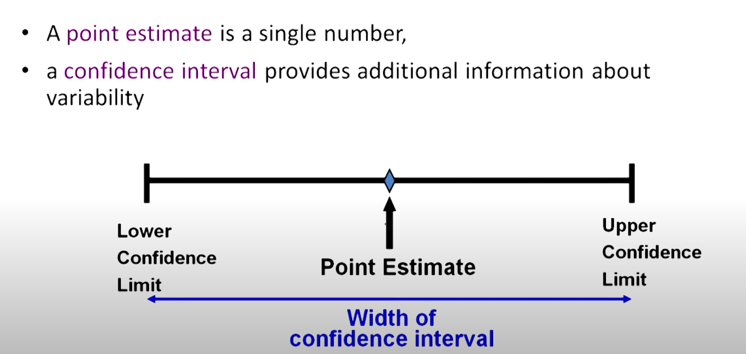

**Unbiasedness means that an estimator gives results that, on average, are equal to the true population parameter when we take multiple samples.**

Some interval estimate provides more information about a population such interval estimates are called confidence intervals.it gives a range of values

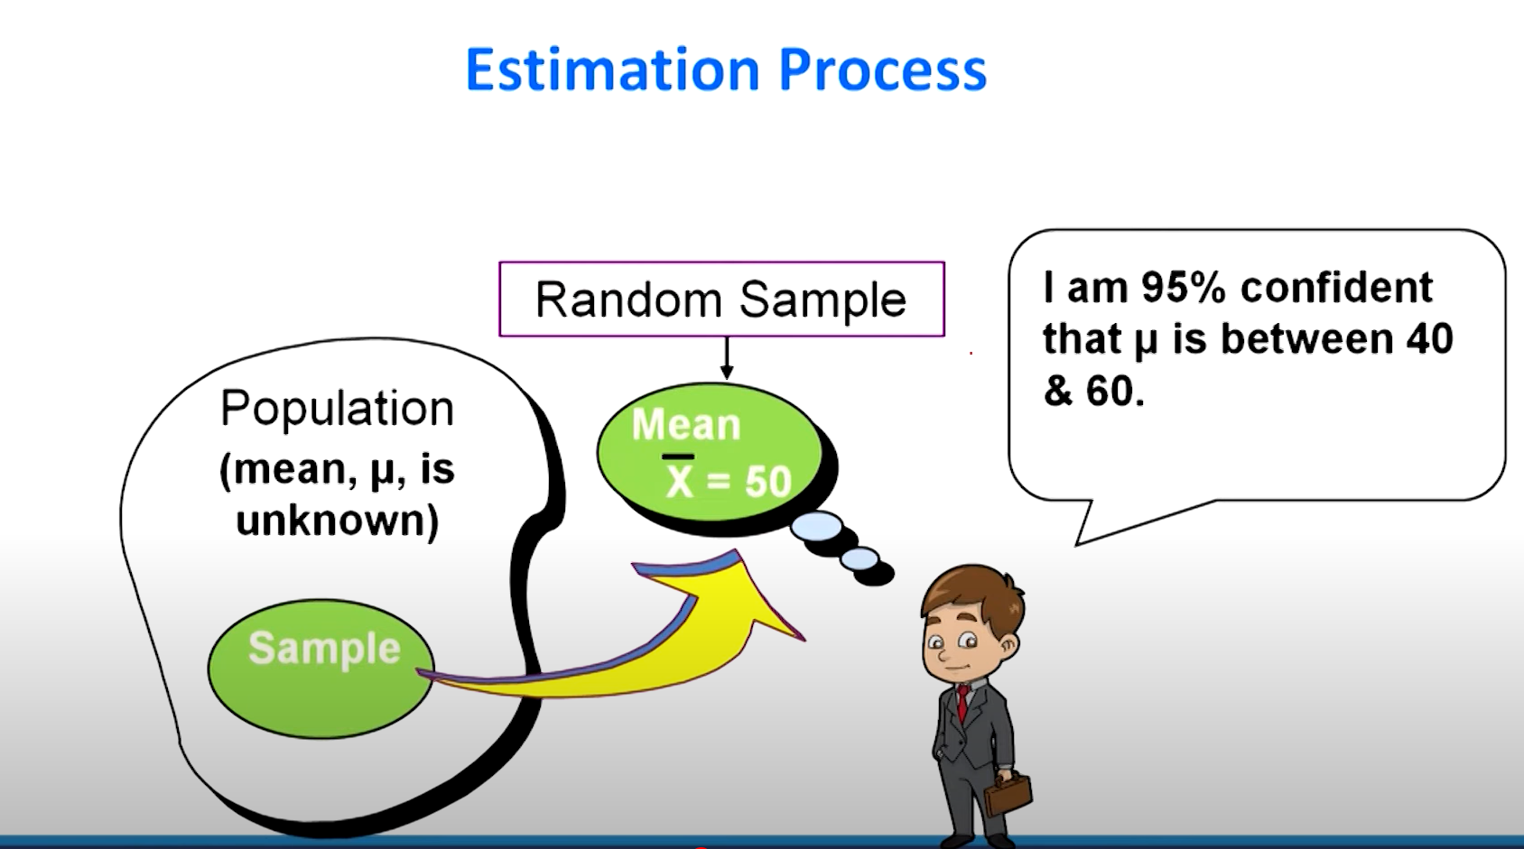

✔ **Population Mean (μ):** True average of a population.  
✔ **Population Proportion (p):** True fraction of a population with a characteristic.  
✔ **Population Variance (σ²):** True measure of how spread out the data is.  
✔ **Confidence Interval (CI):** A range that likely contains the true parameter.  
✔ **Sigma Known vs. Unknown:** If **σ² is known, use Z-distribution**; if **unknown, use t-distribution**.

## Hypothesis testing

* **Null Hypothesis (H0​)** → The assumption that there is **no effect** or **no difference**.
* **Alternative Hypothesis (H1**→ The assumption that there **is an effect** or **a significant difference**.

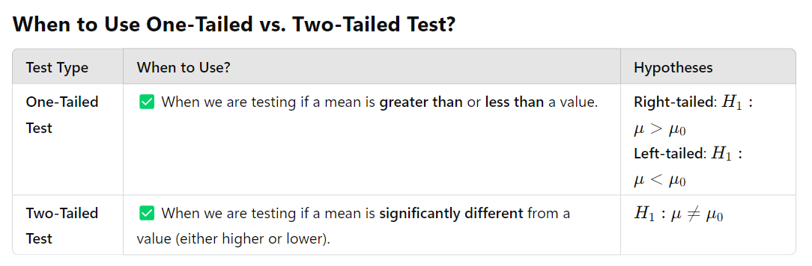

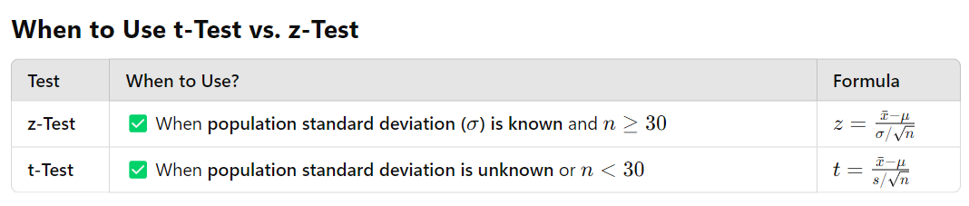

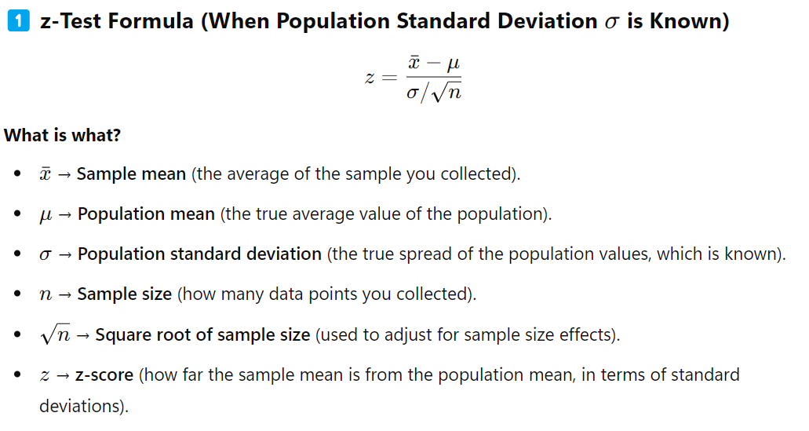

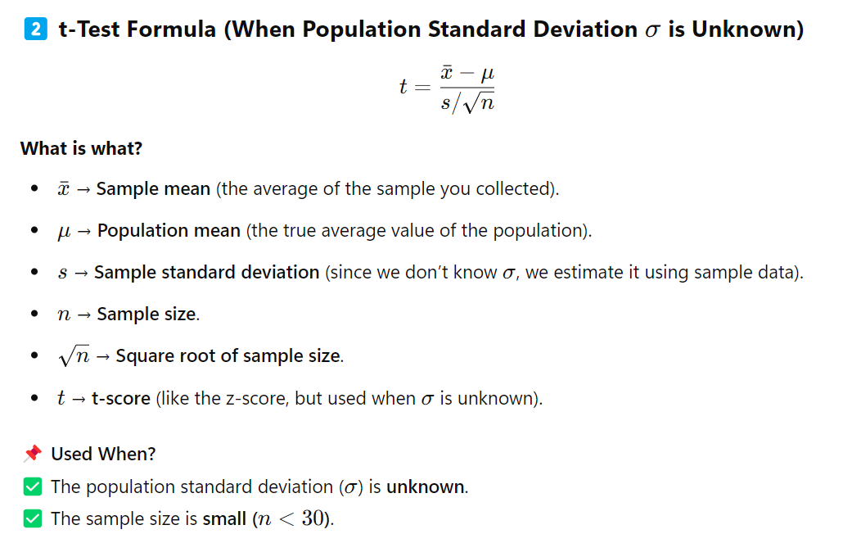

**Degrees of freedom(d) = n-1**

**By considering this df value and choose associated table value and then compare it with the critical value.**

